Ideation Phase
Empathize & Discover

Date | 27.09.2026
Team ID | 6ab1d5c192b876d9664095f0
Project Name | Streamlining IT procurement: Automating stardard laptop orders with flow designer
Maximum Marks | 4 Marks

Empathy Map Canvas:

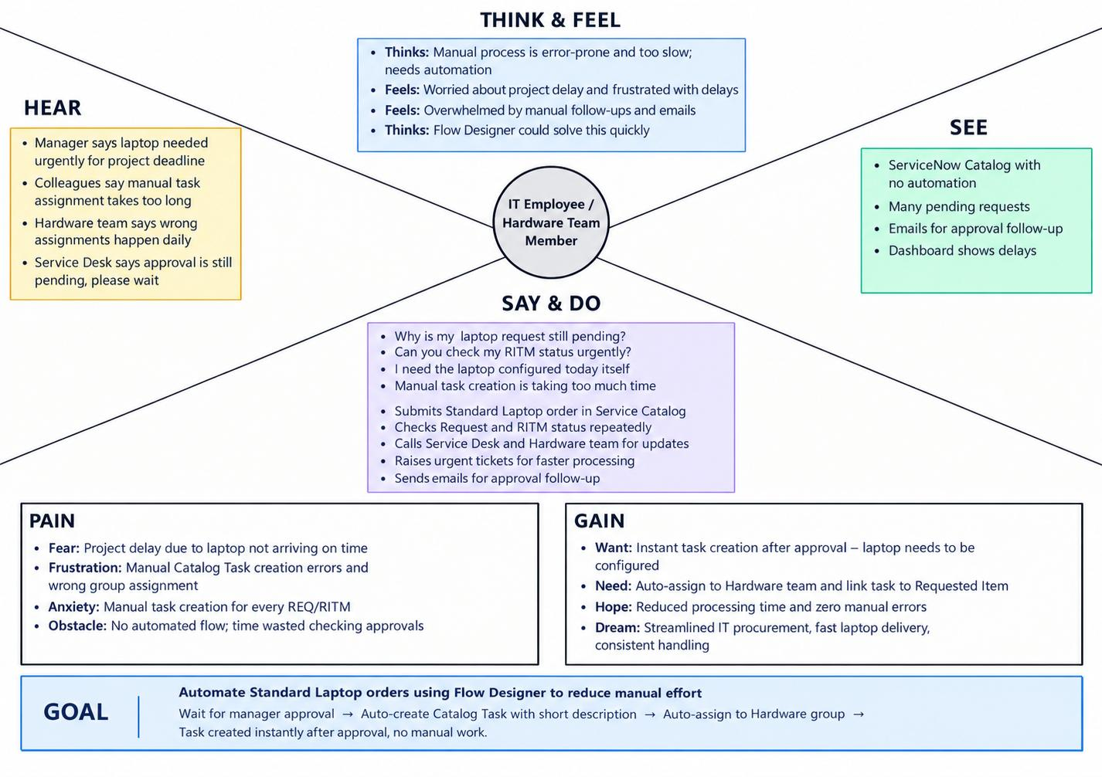
Example: Streamlining IT procurement: Automating stardard laptop orders with flowdesigner

